HW 4 Log
ESAM 372-0
Rohan Krishnamurthi
11/25/2024

NOTES
Differential Expression Analysis – 1
- DESeq2: R software package used for differential analysis of genes
- Read count table should have 6 samples from each condition (WT, SNF2 mutant)
R Code:
- Install and load packages
  - BiocManager, DESeq2, GenomeInfoDbData (source)
- Read in count tables
- Make sample table from count table
- Make DESeq data set form count table
- Run DESeq2, extract normalized counts, write them to a file
- Compare SNF2 mutant and WT samples, using results function
  - Can use log2 fold change threshold, or not
- Merge normalized counts and fold changes

Visualizing DESeq2 Results
- MA plots to summarize fold change results: plotMA(yeast_results, ylim=c(-2.5, 2.5))
- Shrinking of log fold changes first
  - yeastLFC <- lfcShrink(yeast_results, coef=”condition_SNF2_vs_WT”, lfcThreshold=0.5)
  - plotMA(yeastLFC, ylim=c(-2.5, 2.5))
- Heatmaps made with variance stabilized data
  - vsd <- vst(DDS_yeast_result, blind=FALSE)
  - library(“pheatmap”)
  - select <- order(rowMeans(counts(DDS_yeast_result, normalized=TRUE)), decreasing=TRUE) [1:20]
  - df <- as.data.frame(colData(DDS_yeast_result)[,c(“condition”,”sample”)])
  - pheatmap(assay(vsd)[select,], cluster_rows=TRUE, show_rownames=TRUE, cluster_cols=TRUE, annotation_col=df)
- Pull out top 20 rows for mean expression
  - select <- order(rowMeans(counts(DDS_yeast_result, normalized=TRUE)), decreasing=TRUE)[1:20]
- Principal Component Analysis (PCA)
  - pcaData <- plotPCA(vsd, intgroup=c(“condition”, “sample”), returnData=TRUE)
  - percentVar <- round(100 * attr(pcaData, “percentVar”))
  - ggplot(pcaData, aes(PC1, PC2, color=sample, shape=condition)) + coord_fixed(ratio = sqrt(percentVar[2]/percentVar[1])) + geom_point(size = 3) + xlab(paste0(“PC1: “, percentVar[1], “% variance”)) + ylab(paste0(“PC2: “ percentVar[2], “% variance”))

Differential Expression with 6 Replicates
Making new count table (with replacements) in Quest:
- Project Directory: projects/e31265/rsk9305/hw_3
- Move SNF2_06 and WT_21 to hw_3 folder
- awk -f build_count_table.awk count_table_files_4.txt > count_table_4.txt
- Folder saved on local directory: count_table_replacements_2.txt

Problem 1
- R script: 4A.R
- Output Files: yeast_combined_threshold_1.csv
- Number of differentially expressed genes that have an adjusted p-value of 0.05 or smaller: 547 (out of 7127)
Problem 2
- R script: 4B.R
- Output Files: yeast_combined_threshold_2.csv
- Number w/ p-value of 0.05 or smaller: 317 (out of 7127, old is 408)
Problem 3
- R script: 4C.R
- Number w/ p-value of 0.05 or smaller: 274 (out of 7127)
Problem 4
- R script: 4D.R
- Number w/ p-value of 0.05 or smaller: 140 (out of 7127, old is 162)
Problem 5
- Question: is the change in the number of differentially expressed genes change substantial due to a) the variation in the number of replicates; b) the quality of samples included?
- Replacing good samples with bad samples moderately lowers the resulting number of differentially expressed genes.
- Lowering variation in the number of replicates significantly lowers the resulting number of differentially expressed genes.
- Are the replacements SNF2_06 and WT_21 considered bad samples, worse quality?

Visualizing DESeq2 Results
Problem 6
- Generate heatmap and PCA for 12 good samples
- R script: 4A.R
- Output: heatmap_1.jpeg, PCA_1.jpeg
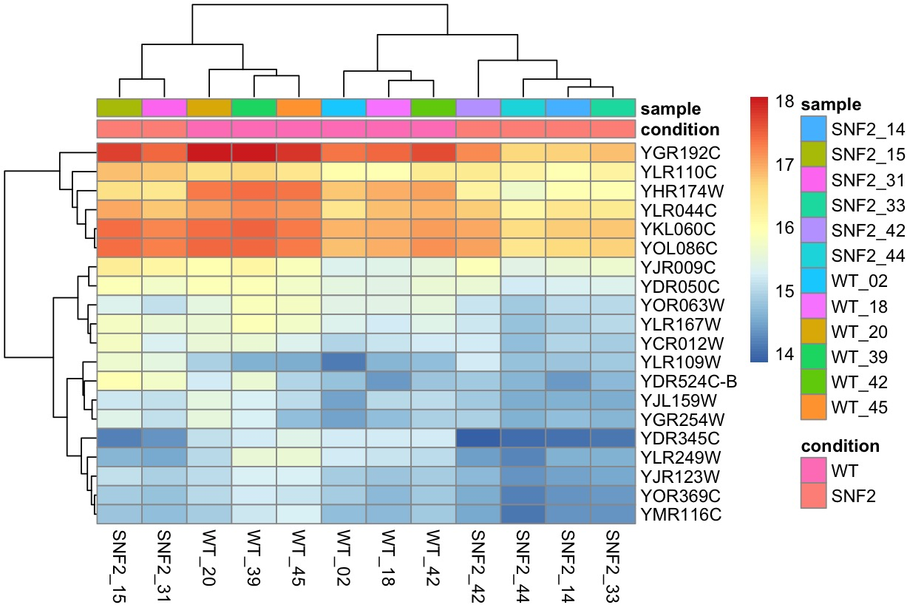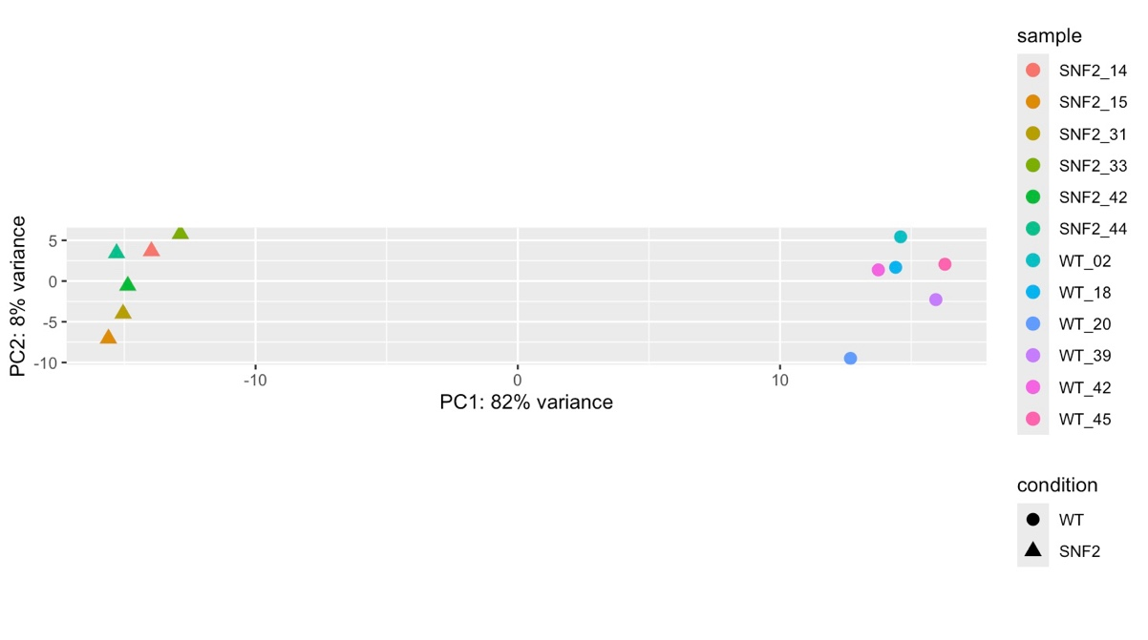

Problem 7
- Generate second heatmap, using 30 genes w/ greatest mean
- R script: 4A.R
- Output: heatmap_2.jpeg

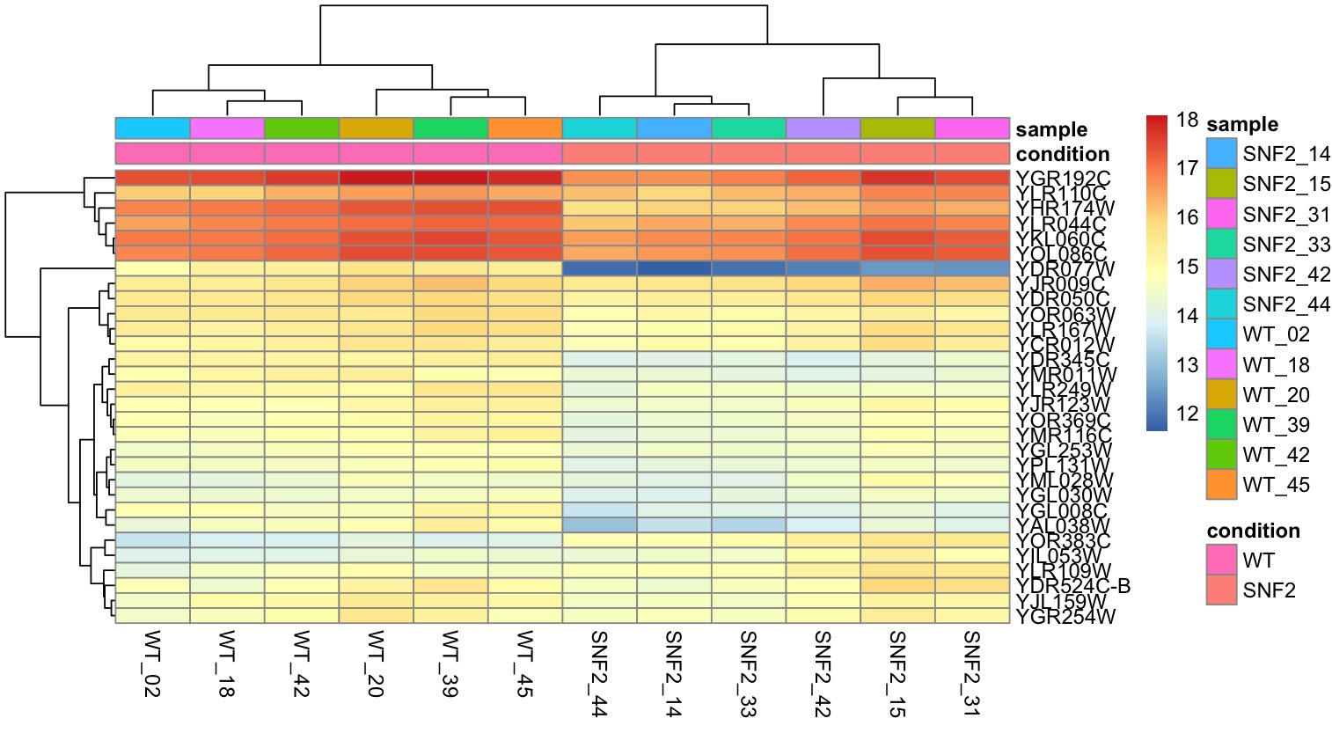

Problem 8
- Generate third heatmap, using 30 genes w/ greatest variance
- R script: 4A.R
- Output: heatmap_3.jpeg
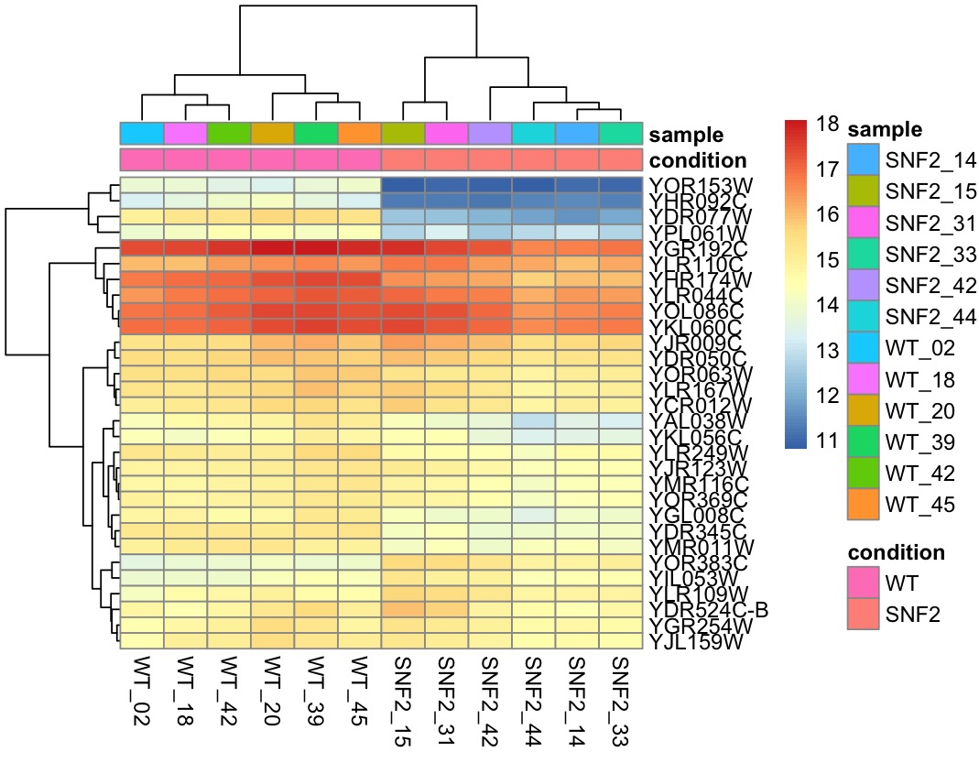

Problem 9
- Generate second PCA, using 5000 genes with the greatest variance
- R script: 4A.R
- Output: PCA_2.jpeg
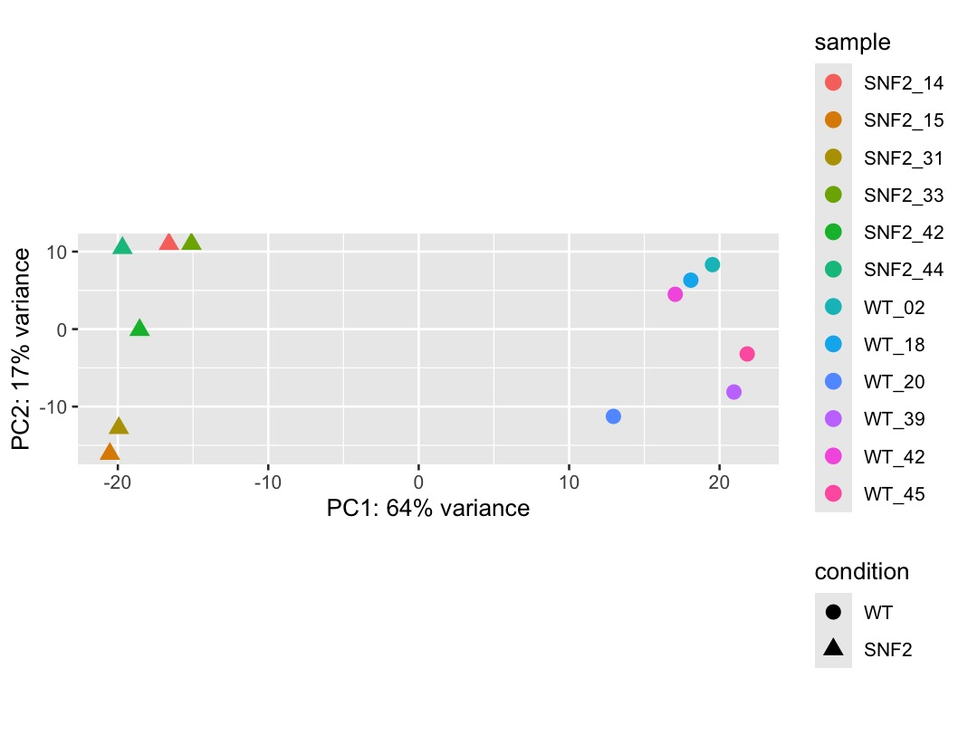

Problem 10: observations
- The PCA is fairly affected by changes in the number of genes with greatest variance used.

